Customer Churn Prediction and Analytics Using Machine Learning

A Project Report Submitted in
the partial fulfillment of the requirements for the award of the degree of

BACHELOR OF TECHNOLOGY
in

DEPARTMENT OF CSE
By
G. SARANYA | :2420030071
B. HASINI | :2420030324
T. NANDINI | :2420030325

Under the Esteemed Guidance of

Dr. N. Sunanda
Associate Professor

Department of CSE

AY: 2026-2027

Semester: Odd Semester




K L (Deemed to be) University DEPARTMENT OF COMPUTER SCIENCE AND ENGINEERING

Declaration

The Project Report entitled “Customer Churn Prediction and Analytics Using Machine Learning” is a record of Bonafide work of G. SARANYA – 2420030071, B. HASINI – 2420030324, T. NANDINI – 2420030325 submitted in partial fulfillment for the award of B. Tech in CSE to the K L University. The results embodied in this report have not been copied from any other departments/University/Institute.

G. SARANYA – 2420030071
B. HASINI – 2420030324
T. NANDINI – 2420030325

K L (Deemed to be) University DEPARTMENT OF COMPUTER SCIENCE AND ENGINEERING

CERTIFICATE

This is to certify that the project report entitled "CUSTOMER CHURN PREDICTION AND ANALYTICS USING MACHINE LEARNING" is a Bonafide work carried out and submitted by Saranya (Reg. No: 2420030071), Hasini (Reg. No: 2420030324) and Nandini (Reg. No: 2420030325) in partial fulfilment of the requirements for the award of the degree of BACHELOR OF TECHNOLOGY in Department of Computer Science and Engineering, K L (Deemed to be) University, during the academic year 2026–2027.

Signature of the Guide
Dr. N. Sunanda
Associate Professor, CSE

Signature of the Course Coordinator Signature of the HOD
Dr. N. Sunanda Dr.P. Venkateswara Rao Department of CSE Department of CSE

ACKNOWLEDGEMENT
The success in this project would not have been possible but for the timely help and guidance rendered by many people. Our wish to express my sincere thanks to all those who has assisted us in one way or the other for the completion of my project.

Our greatest appreciation to my guide Dr.N.SUNANDA. Department of CSE which cannot be expressed in words for her tremendous support, encouragement and guidance for this project.

We express our gratitude to Dr.P.VENKATESWARA RAO, Head of the Department of CSE for providing us with adequate facilities, ways and means by which we are able to complete this project-based Lab.

We thank all the members of teaching and non-teaching staff members, and also who have assisted me directly or indirectly for successful completion of this project. Finally, I sincerely thank my parents, friends and classmates for their kind help and cooperation during my work.

G. SARANYA – 2420030071
B. HASINI – 2420030324
T. NANDINI – 2420030325

Abstract
Customer churn is one of the major challenges faced by businesses in today’s competitive market. It refers to the situation where customers stop purchasing products or discontinue their relationship with a business. In online shopping the problem is even sharper, because a customer can move to another app in a single click. Losing existing customers reduces revenue, profitability and long-term growth, and winning a new customer costs far more than keeping an existing one. Predicting customer churn in advance is therefore essential for improving customer retention.

This project, Customer Churn Prediction and Analytics Using Machine Learning, analyses historical e-commerce product purchase data and customer purchasing behaviour to identify customers who are likely to stop buying. A public e-commerce customer churn dataset of 5,630 customers was cleaned (556 repeated rows removed, leaving 5,074 customers), explored with charts, encoded, scaled and balanced with SMOTE. Five machine learning algorithms – Logistic Regression, Decision Tree, Support Vector Machine, Random Forest and XGBoost – were trained and compared using accuracy, precision, recall, F1-score and ROC-AUC. XGBoost performed best, with 96.7% accuracy, 86.9% recall and an AUC of 0.985 on 1,015 unseen test customers.

The analysis shows that customer tenure and complaints are the strongest drivers of churn: 51.3% of customers in their first month leave, and 31.3% of customers who complain leave compared with 10.8% of those who do not. Each customer’s churn probability is converted into Low, Medium or High risk groups, and 94.3% of customers in the High-risk group really left. A web dashboard presents purchase activity, product-wise churn and purchase-based churn risk, and suggests retention actions such as welcome coupons, faster complaint handling, extra cashback and win-back offers. Overall, the project helps businesses understand purchasing patterns, reduce customer loss and improve long-term profitability.

Keywords: Customer Churn, E-Commerce, Machine Learning, Logistic Regression, Decision Tree, SVM, Random Forest, XGBoost, SMOTE, Customer Retention, Risk Groups

Index
S. No. | Chapters | Topics | Page.no
 |  | Acknowledgement
 |  | Abstract
1 | Introduction | 1.1 Background of the project  1.2 Problem statement  1.3 Scope of the project  1.4 Objective(s)  1.5 Importance of the application  1.6 Target users/audience | 1-3
2 | System Requirements | 2.1 Hardware requirements  2.2 Software requirements  2.3 Development tools and frameworks | 4-5
3 | Technology Stack | 3.1 Front-end (e.g., React.js, Angular, HTML/CSS)  3.2 Back-end (e.g., Node.js, Django, Spring Boot)  3.3 Database (e.g., MongoDB, MySQL, PostgreSQL)  3.4 Version Control (e.g., Git, GitHub)  3.5 APIs or External services (e.g., Firebase, Stripe) | 6-7
4 | System Architecture | 4.1 High-level architecture diagram  4.2 Description of each layer (frontend, backend, database)  4.3 Deployment architecture (e.g., cloud, local, CI/CD pipelines) | 8-10
5 | Design | 5.1 Wireframes or mockups  5.2 ER Diagram / Database schema | 11-13
6 | Implementation | 6.1 Module-wise implementation  6.2 Front-end logic (UI rendering, state management)  6.3 Backend logic (routes, controllers, business logic)  6.4 Database connectivity  6.5 API integration  6.6 Authentication & Authorization | 14-16
7 | Features | 7.1 List of main features  7.2 How each feature works (user perspective + technical description) | 17-18
8 | Testing | 8.1 Postman testing (frontend/backend)  8.2 Integration testing  8.3 Tools used for testing  8.4 Test cases and results | 19-24
9 | Deployment | 9.1 Steps to deploy  9.2 Environment configuration  9.3 Hosting of frontend and backend | 25-26
10 | Challenges & Limitations | 10.1 Issues faced during development  10.2 Solutions applied  10.3 Current limitations or known bugs | 27-28
11 | Future Enhancements | 11.1 Planned features  11.2 Possible integrations or optimizations | 29
12 | Conclusion | 12.1 Summary of the project  12.2 What was achieved  12.3 Skills learned during development | 30-31
13 | References | - Books, tutorials, APIs, documentation sites used | 32
14 | Appendices | - Screenshots of the app  - Sample code snippets  - Installation/setup instructions  - User manual or guide  -certifications | 33-35

CHAPTER 1
Introduction

1.1 Background of the project
Online shopping has changed the way people buy products. E-commerce platforms offer a huge choice of products, frequent discounts and fast delivery, and a customer can compare and switch between shopping apps within seconds. This convenience has made the market highly competitive, and keeping existing customers has become as important as attracting new ones. Customer churn is the situation in which a customer stops purchasing from a business or discontinues the relationship altogether.
Churn directly reduces sales and profit. Studies in customer relationship management commonly report that acquiring a new customer costs five to twenty-five times more than retaining an existing one, so even a small reduction in churn has a large effect on profitability. Traditionally, businesses noticed churn only after customers had already gone – for example, when sales of a product dropped or a loyal buyer stopped ordering. By then it is usually too late to win the customer back.
Every online shop already records a large amount of data about its customers: how long they have been with the shop, how often they order, which categories they buy, whether they use coupons, whether they raised a complaint and how much cashback they received. Machine learning algorithms can learn the patterns hidden in this purchase history and estimate which current customers are likely to leave. Customer Churn Prediction and Analytics Using Machine Learning is built on this idea.
1.2 Problem statement
Shops have plenty of customer data but do not know who will leave next. Without proper analysis it is difficult to identify potential churners early, to understand why they leave, and to decide what action to take. Many earlier churn studies use telecom data rather than online shopping data, and repeated rows in public datasets can make model scores look better than they really are.
The problem addressed in this project is: how can historical e-commerce purchase data be used to predict which customers are likely to stop buying, explain the main reasons for churn, and group customers into risk levels so that the business can take timely retention actions?
1.3 Scope of the project
The scope of the project covers the complete data science workflow for customer churn analysis:
- Collection and understanding of a public e-commerce customer churn dataset (5,630 customers, 20 columns).
- Data preprocessing: removing 556 repeated rows, filling missing values, encoding text columns and scaling numeric columns.
- Exploratory data analysis to find churn patterns such as tenure, complaints, device and marital status.
- Balancing the classes with SMOTE and training five models: Logistic Regression, Decision Tree, SVM, Random Forest and XGBoost.
- Prediction of each customer’s churn probability and grouping into Low, Medium and High risk.
- A web dashboard that shows purchase activity, product-wise churn and purchase-based churn risk with suggested actions.

The project is a decision-support tool. It does not send offers automatically, process payments or replace the judgement of the business owner; it highlights who needs attention and why.
1.4 Objective(s)
- To collect and clean e-commerce product purchase data so that it is ready for analysis.
- To find the main reasons why buyers stop purchasing products.
- To build machine learning models that predict which customers will stop buying.
- To compare the models using accuracy, precision, recall, F1-score and ROC-AUC and select the most reliable one.
- To identify high-risk buyers by grouping customers into Low, Medium and High risk.
- To suggest offers and cashback that bring buyers back, reduce lost sales and support better business decisions.

1.5 Importance of the application
- Reduces lost sales: customers who are about to leave are found early, while they can still be won back.
- Saves marketing money: offers are targeted at high-risk customers instead of being given to everyone.
- Explains churn: feature importance shows which factors – tenure, complaints, cashback – drive customers away.
- Improves customer experience: complaints and first-month problems are identified as key moments to act on.
- Supports planning: product-wise churn helps the business plan deals, coupons and stock.
- Consistent decisions: the same model scores every customer, reducing guesswork.

1.6 Target users/audience
User | How the system helps
E-commerce businesses | Identify customers who are likely to stop buying and reduce lost sales.
Marketing teams | Target coupons, cashback and win-back messages at high-risk customers.
Customer support teams | Prioritise complaints from customers who are most likely to leave.
Product and category managers | See product-wise churn and plan deals and stock.
Students and researchers | Use the project as a reference for applying data science to customer retention.

CHAPTER 2
System Requirements

2.1 Hardware requirements
The hardware needed for development and for running the system is modest, because the purchase dataset is tabular and of moderate size (about 5,600 rows).
Component | Minimum requirement | Recommended
Processor | Intel Core i3 / AMD Ryzen 3 (dual core) | Intel Core i5 / AMD Ryzen 5 or higher
RAM | 4 GB | 8 GB or more
Storage | 10 GB free disk space | 256 GB SSD
Display | 1366 x 768 resolution | 1920 x 1080 resolution
Network | Internet connection for package installation | Stable high-speed internet
GPU | Not required | Not required for these models

2.2 Software requirements
Software | Details
Operating system | Windows 10/11, Ubuntu 20.04 or later, or macOS
Programming language | Python 3.10 or later; HTML, CSS and JavaScript for the web pages
Data science libraries | NumPy, pandas, scikit-learn, XGBoost, imbalanced-learn (SMOTE)
Visualization libraries | Matplotlib, Seaborn; charts in the web dashboard
Web framework | Bootstrap (front-end), Flask (Python back-end)
Database | CSV files for the dataset; SQLite for purchase history and predictions
Web browser | Google Chrome, Microsoft Edge or Mozilla Firefox (latest version)
Other tools | Git and GitHub, Jupyter Notebook / Google Colab, Visual Studio Code

2.3 Development tools and frameworks
- Jupyter Notebook / Google Colab: exploratory data analysis, experimentation and model comparison.
- Visual Studio Code / Brackets: writing the HTML, CSS and JavaScript of the web pages and the Python modules.
- pandas and NumPy: loading, cleaning and transforming the purchase data.
- scikit-learn: preprocessing, Logistic Regression, Decision Tree, SVM, Random Forest and evaluation metrics.
- XGBoost: gradient-boosted tree ensemble, the best-performing model in this project.
- imbalanced-learn: SMOTE oversampling to balance churners and non-churners in the training data.
- Bootstrap: responsive layout, cards, tables and buttons for the dashboard.
- Git and GitHub: version control and collaboration between the team members.

CHAPTER 3
Technology Stack

3.1 Front-end (e.g., React.js, Angular, HTML/CSS)
The user interface is a web dashboard built with HTML, CSS and JavaScript, using the Bootstrap framework for a clean, responsive, mobile-friendly layout. The dashboard has three main pages: an Overview page with key figures (total customers, 90-day churn rate, active customers at risk, sales) and charts of purchase activity and churn by category; a Products page where the user chooses a company, category and product to see buyers showing signs of churn; and a Churn Predictions page where purchase behaviour is entered to estimate a customer’s churn risk.
3.2 Back-end (e.g., Node.js, Django, Spring Boot)
The back-end is written in Python. The core is a machine learning pipeline built with pandas, NumPy, scikit-learn and imbalanced-learn, with XGBoost as the final model. The trained model is saved with joblib and served through a lightweight Flask service, which validates the input sent by the web page, calls the model and returns the churn probability, risk group and suggested action in JSON format.
3.3 Database (e.g., MongoDB, MySQL, PostgreSQL)
The training data is the public e-commerce customer churn dataset stored as a CSV file. Customer, product, order and prediction records used by the dashboard are stored in a relational SQLite database, which needs no installation and can later be migrated to MySQL or PostgreSQL without changing the schema. Relational storage suits this project because the data is structured and the entities (customers, products, orders, predictions) are naturally linked by keys.
3.4 Version Control (e.g., Git, GitHub)
The source code, notebooks and documentation are maintained in a Git repository hosted on GitHub. Each team member works on a separate branch for their module, and the commit history provides a record of how the project evolved.
3.5 APIs or External services (e.g., Firebase, Stripe)
- Churn prediction API (internal): the /predict endpoint used by the Churn Predictions page.
- Kaggle: source of the public “E-Commerce Customer Churn Analysis and Prediction” dataset.
- Bootstrap CDN: delivers the Bootstrap CSS and JavaScript files to the web pages.
- Export report: the dashboard exports customer and product churn summaries for the marketing team.
- SMS / e-mail services (future scope): to send win-back messages to high-risk customers automatically.

CHAPTER 4
System Architecture

4.1 High-level architecture diagram
The system follows a layered architecture in which each layer has a single responsibility. The presentation layer talks only to the API layer, the API layer calls the machine learning layer, and the machine learning layer reads and writes the data layer.
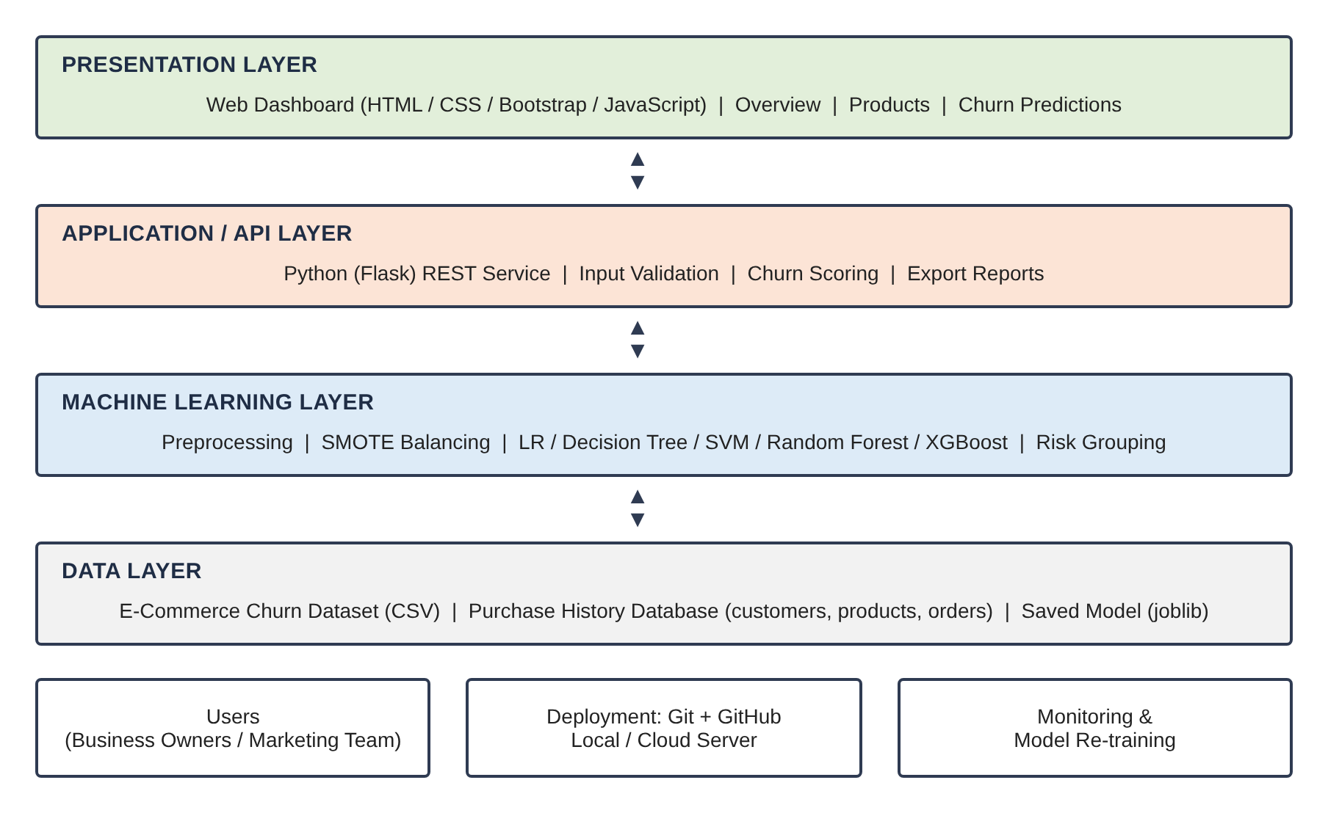
Fig No. 4.1 High-level architecture of the Customer Churn Prediction system
The data science workflow that runs inside the machine learning layer is shown below. Raw purchase data is the input; preprocessing, SMOTE balancing, model training and evaluation form the processing stage; and churn probability, risk groups and retention actions are the outputs.
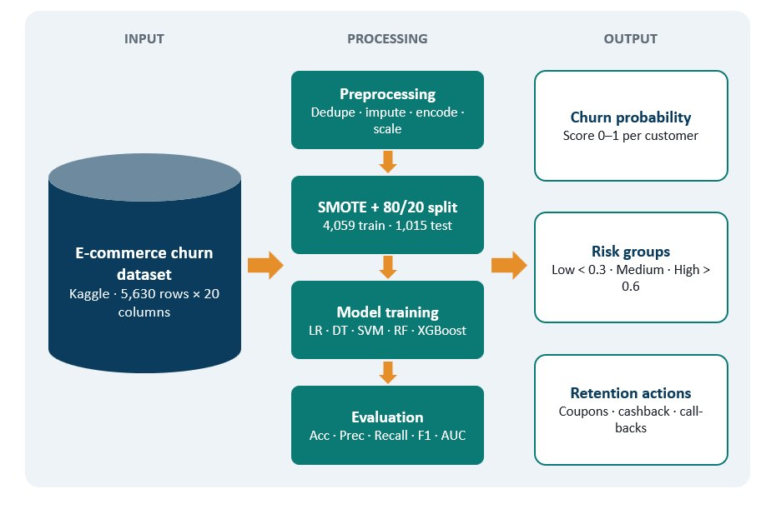
Fig No. 4.2 Machine learning workflow (Input → Processing → Output)
4.2 Description of each layer (frontend, backend, database)
Presentation layer (front-end)
This layer contains the web dashboard built with HTML, CSS, Bootstrap and JavaScript. It shows the overview figures and charts, the product catalogue with buyers at risk, and the churn prediction form. It contains no business logic; it only collects input and displays results.
Application / API layer (back-end)
The Flask service receives requests from the dashboard, validates every field (type, range and required values), passes the data to the model and returns the result. It also prepares the data for the overview charts and the exported reports. Keeping this layer separate makes it possible to connect other systems, such as a shop’s CRM, to the same model.
Machine learning layer
This layer holds the preprocessing steps (duplicate removal, median imputation, encoding, scaling), SMOTE balancing and the five trained classifiers. XGBoost, the best model, outputs a churn probability between 0 and 1, which is converted into Low (below 0.3), Medium (0.3 to 0.6) or High (above 0.6) risk.
Data layer (database)
The data layer stores the e-commerce churn dataset used for training, the database of customers, products, orders and predictions used by the dashboard, and the saved model file. Each prediction is stored with the model version so that results can be reviewed later.
4.3 Deployment architecture (e.g., cloud, local, CI/CD pipelines)
During development the application runs on a local machine. For deployment, code is pushed to GitHub, the model and application are tested, and the passing build is deployed to a server where the API and dashboard are served to users through a web browser.
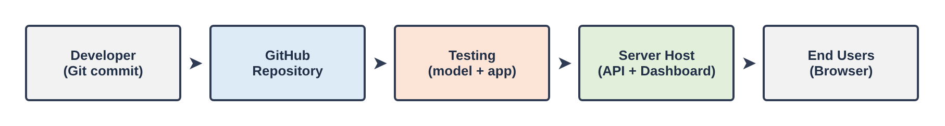
Fig No. 4.3 Deployment architecture

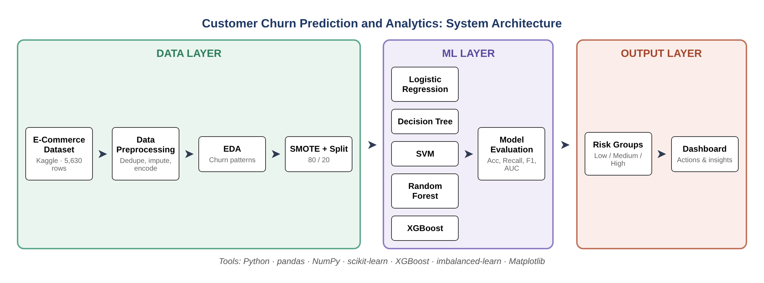
Fig No. 4.4 Detailed system architecture

CHAPTER 5
Design

5.1 Wireframes or mockups
The Churn Predictions screen is designed as a single page so that a business user can enter a customer’s purchase behaviour on the left and immediately see the result on the right. The wireframe below shows the intended layout.
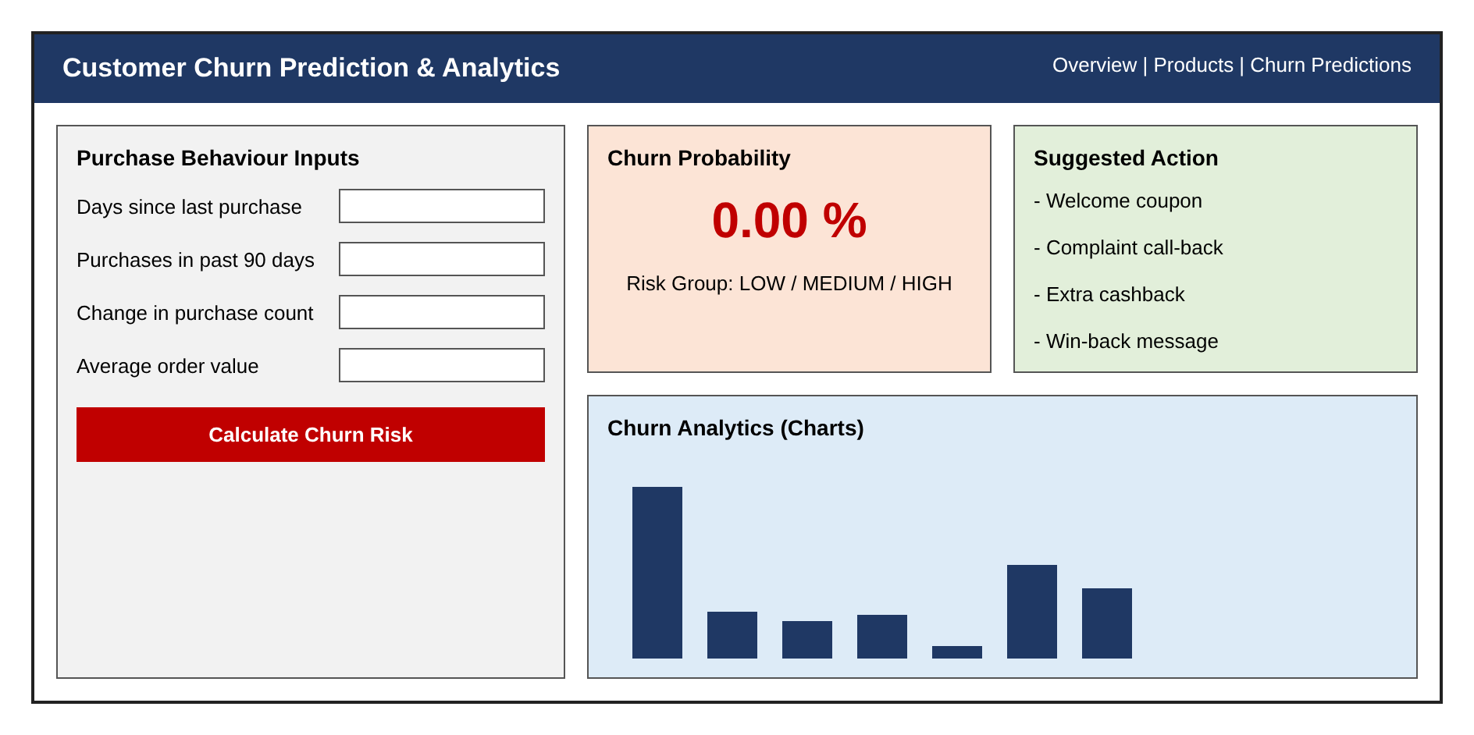
Fig No. 5.1 Wireframe of the churn prediction screen
The screen has four areas: (1) the Purchase Behaviour Inputs form – days since last purchase, purchases in the past 90 days, change in purchase count and average order value; (2) the Churn Probability card with the risk group; (3) the Suggested Action panel listing the retention step for that customer; and (4) Churn Analytics charts for managers.
Data Flow Diagram
At the highest level, the business user supplies customer purchase details to the system and receives a churn risk and a suggested action. The system reads the e-commerce purchase dataset to train the model and uses the model store to save and load the trained model.
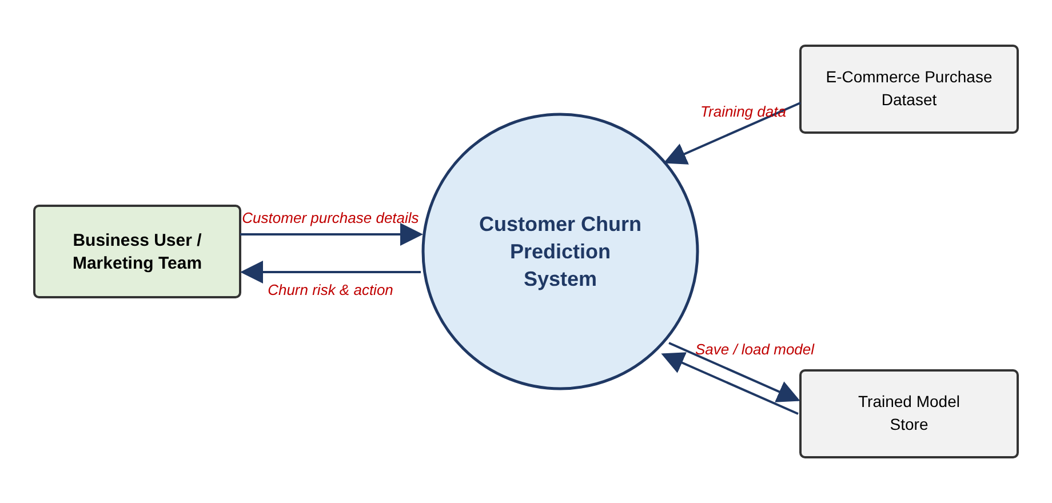
Fig No. 5.2 DFD Level-0 of the Customer Churn Prediction system
5.2 ER Diagram / Database schema
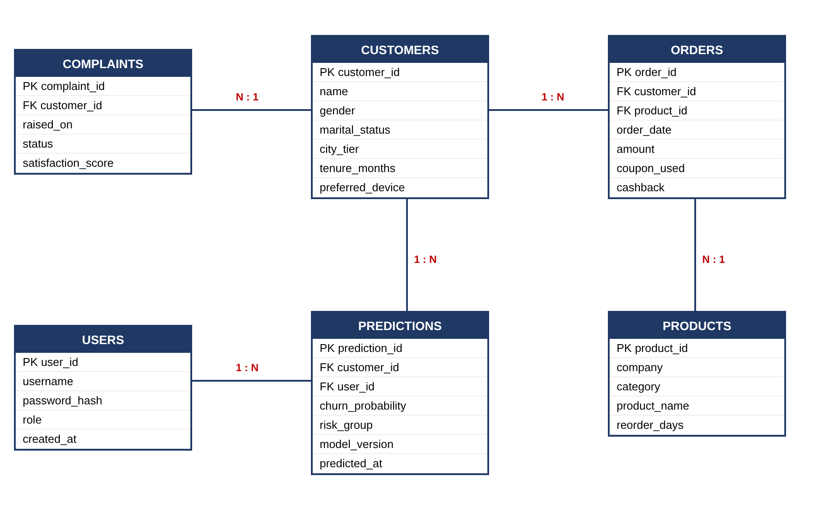
Fig No. 5.3 Entity-Relationship diagram
The main tables of the schema are listed below. PK denotes the primary key and FK a foreign key.
Table | Important columns | Purpose
users | user_id (PK), username, password_hash, role, created_at | Login accounts for business owners, analysts and admins
customers | customer_id (PK), name, gender, marital_status, city_tier, tenure_months, preferred_device | Basic and demographic details of each customer
products | product_id (PK), company, category, product_name, reorder_days | Product catalogue and typical reorder cycle
orders | order_id (PK), customer_id (FK), product_id (FK), order_date, amount, coupon_used, cashback | Purchase history used for behavioural features
complaints | complaint_id (PK), customer_id (FK), raised_on, status, satisfaction_score | Complaints and satisfaction, a key churn signal
predictions | prediction_id (PK), customer_id (FK), user_id (FK), churn_probability, risk_group, model_version, predicted_at | Stored model outputs for review and analytics

CHAPTER 6
Implementation

6.1 Module-wise implementation
The project is divided into independent modules, each implemented as a Python module, notebook section or web page.
Module | Description
Data collection | Loads the e-commerce churn dataset (5,630 rows, 20 columns) into a pandas data frame; checks structure, data types and the share of churners (16.6%).
Data preprocessing | Removes 556 repeated rows (5,074 customers remain), fills missing values with the column median, encodes text columns (e.g. Male / Female → 0 / 1) and scales numeric columns.
Exploratory data analysis | Studies churn by tenure, complaints, device, marital status and order category with charts to find the main churn patterns.
Balancing and splitting | Splits the data 80 / 20 (4,059 training and 1,015 test customers) and applies SMOTE only to the training data, because only 1 in 6 customers left.
Model training | Trains Logistic Regression, Decision Tree, SVM, Random Forest and XGBoost on the balanced training data.
Model evaluation | Compares models on accuracy, precision, recall, F1-score and ROC-AUC using the 1,015 unseen test customers; selects XGBoost.
Risk grouping and actions | Converts the churn probability into Low, Medium or High risk and attaches a suggested retention action.
Web dashboard | Overview, Products and Churn Predictions pages built with HTML, CSS, Bootstrap and JavaScript.

The churn probability is converted into a risk group as follows (the thresholds can be tuned by the business):
Churn probability | Risk group | Suggested action
Below 0.30 | Low (1.3% really left) | No extra spend; keep normal engagement
0.30 to 0.60 | Medium (48.0% really left) | Win-back message with a special deal
Above 0.60 | High (94.3% really left) | Extra cashback and complaint call-back within 24 hours

6.2 Front-end logic (UI rendering, state management)
The web pages are written in HTML and styled with CSS and Bootstrap cards, tables and buttons. On the Churn Predictions page, JavaScript reads the values entered in the form (days since last purchase, purchases in the past 90 days, change in purchase count and average order value), checks that they are valid numbers and sends them to the prediction API when the user presses Calculate churn risk. The returned churn probability is shown in a result card and the risk group is colour coded (green, amber, red). The Overview page renders the purchase activity line chart, the churn-by-category chart and the “Customers to watch” table, and the Products page filters products by company and category.
6.3 Backend logic (routes, controllers, business logic)
- POST /predict: validates the input, builds a one-row data frame, calls model.predict_proba, maps the probability to a risk group, attaches the suggested action, stores the record and returns JSON.
- GET /overview: returns total customers, 90-day churn rate, active customers at risk, recent sales and chart data.
- GET /products: returns products filtered by company and category, with buyers at risk and typical reorder days.
- GET /products/<id>: returns product-wise churn, orders over time and buyers with their churn risk.
- Business logic: a customer is labelled churned after 90 days without a purchase; the same preprocessing used in training is applied at prediction time.

6.4 Database connectivity
The back-end connects to the SQLite database through Python’s database connector, using parameterized queries everywhere to prevent SQL injection. Because the schema is standard SQL, the same code can run on MySQL or PostgreSQL by changing only the connection settings.
6.5 API integration
The dashboard calls the prediction API over HTTP using JavaScript fetch requests, sending JSON and receiving JSON. Because the model is behind a REST interface, other applications such as a CRM or an e-mail marketing tool can integrate with the system in the same way.
6.6 Authentication & Authorization
Users log in with a username and password. Passwords are stored only as salted hashes, never in plain text. Role-based authorization separates the permissions of an Admin (manage users, retrain the model), an Analyst (view analytics and export reports) and a Business User (view dashboards and run churn predictions).
CHAPTER 7
Features

7.1 List of main features
- Prediction of the churn probability of each customer.
- Grouping of customers into Low, Medium and High risk.
- Comparison of five models (Logistic Regression, Decision Tree, SVM, Random Forest, XGBoost).
- Explanation of the main reasons for churn using feature importance.
- Overview dashboard with total customers, 90-day churn rate, customers at risk and sales.
- Product catalogue with product-wise churn rate and buyers at risk.
- Purchase-based churn risk calculator using recency, frequency, trend and order value.
- Suggested retention action for each risk group.
- Export of churn reports for the marketing team.

7.2 How each feature works (user perspective + technical description)
Feature | User perspective | Technical description
Churn prediction | The user enters purchase behaviour and presses Calculate churn risk to see the churn probability. | Input is validated, passed through the saved preprocessing steps and XGBoost; predict_proba returns the probability of churn.
Risk groups | The result is shown as Low, Medium or High with a colour. | The probability is compared with thresholds 0.3 and 0.6.
Model comparison | An analyst can see accuracy, precision, recall, F1 and AUC of each model. | Metrics are calculated on 1,015 held-out test customers.
Churn reasons | The user sees which factors push customers to leave. | Random Forest feature importance; tenure (0.211) and complaints (0.063) rank highest.
Overview dashboard | Managers see key figures, purchase activity and churn by category. | Aggregated queries on customers, orders and predictions, rendered as charts.
Product churn | The user picks a company, category and product to see buyers showing signs of churn. | A buyer is flagged when the expected reorder date passes without a repurchase.
Retention actions | Each risk group comes with a clear next step. | Rule table mapping risk group to coupon, cashback, call-back or win-back message.

CHAPTER 8
Testing

8.1 Postman testing (frontend/backend)
The prediction API was designed to be tested with Postman. For each endpoint a request collection is prepared containing valid input, missing fields, wrong data types and out-of-range values (for example negative days since last purchase). The expected response codes are 200 for success and 400 for invalid input. The web pages are tested manually by entering sample customers and checking that the displayed result matches the API response.
8.2 Integration testing
Integration testing checks that the modules work correctly together: the web page sends data to the API, the API loads the saved model, the prediction is stored in the database and the result returns to the screen. A key check is that the same preprocessing is applied in training and in prediction, and that SMOTE is applied only to the training data so that the test results reflect the real mix of churners and non-churners.
8.3 Tools used for testing
- Postman: API request testing.
- scikit-learn metrics: accuracy, precision, recall, F1-score, ROC-AUC and the confusion matrix.
- Jupyter Notebook: validation of data quality (duplicates, missing values) and model behaviour.
- Web browser developer tools: checking page layout, console errors and API calls.

8.4 Test cases and results
The functional test cases for the system are listed below. Model test cases have been executed; the Status of the web application test cases is to be filled in after the final build is tested.
ID | Test case | Expected result | Status
TC01 | Remove repeated rows from the dataset | No duplicates remain (5,074 unique customers) | Pass
TC02 | Load dataset with missing values | Missing cells filled with the median without error | Pass
TC03 | Apply SMOTE to training data only | Test set of 1,015 customers keeps the real class mix | Pass
TC04 | Evaluate XGBoost on unseen test data | Highest accuracy and AUC of all models | Pass
TC05 | Check High-risk group against real churn | Most High-risk customers really left (94.3%) | Pass
TC06 | Submit valid purchase behaviour on Churn Predictions page | Churn probability between 0 and 1 and a risk group shown | [ ]
TC07 | Submit form with an empty or negative field | Input rejected with a clear message | [ ]
TC08 | Open Overview page | Key figures, charts and Customers to watch table are displayed | [ ]
TC09 | Filter Products by company and category | Only matching products are listed | [ ]
TC10 | Open a product detail page | Product churn rate, orders over time and buyers at risk are shown | [ ]

The model performance results obtained on the 1,015 test customers are recorded in the following table:
Model | Accuracy | Precision | Recall | F1-score | ROC-AUC
Logistic Regression | 79.2% | 42.9% | 77.4% | 55.2% | 0.876
Decision Tree | 86.8% | 58.3% | 71.4% | 64.2% | 0.856
SVM | 92.3% | 72.1% | 87.5% | 79.0% | 0.950
Random Forest | 96.4% | 91.2% | 86.3% | 88.7% | 0.985
XGBoost | 96.7% | 93.0% | 86.9% | 89.8% | 0.985

For customer churn, recall of the churn class and ROC-AUC are given more importance than plain accuracy, because churners are only about 1 in 6 customers and a model can show high accuracy while missing most of them. A missed churner is a lost customer, while a false alarm only costs one offer. The confusion matrix of XGBoost shows 836 true negatives, 11 false positives, 22 false negatives and 146 true positives: out of 168 customers who left, XGBoost found 146.
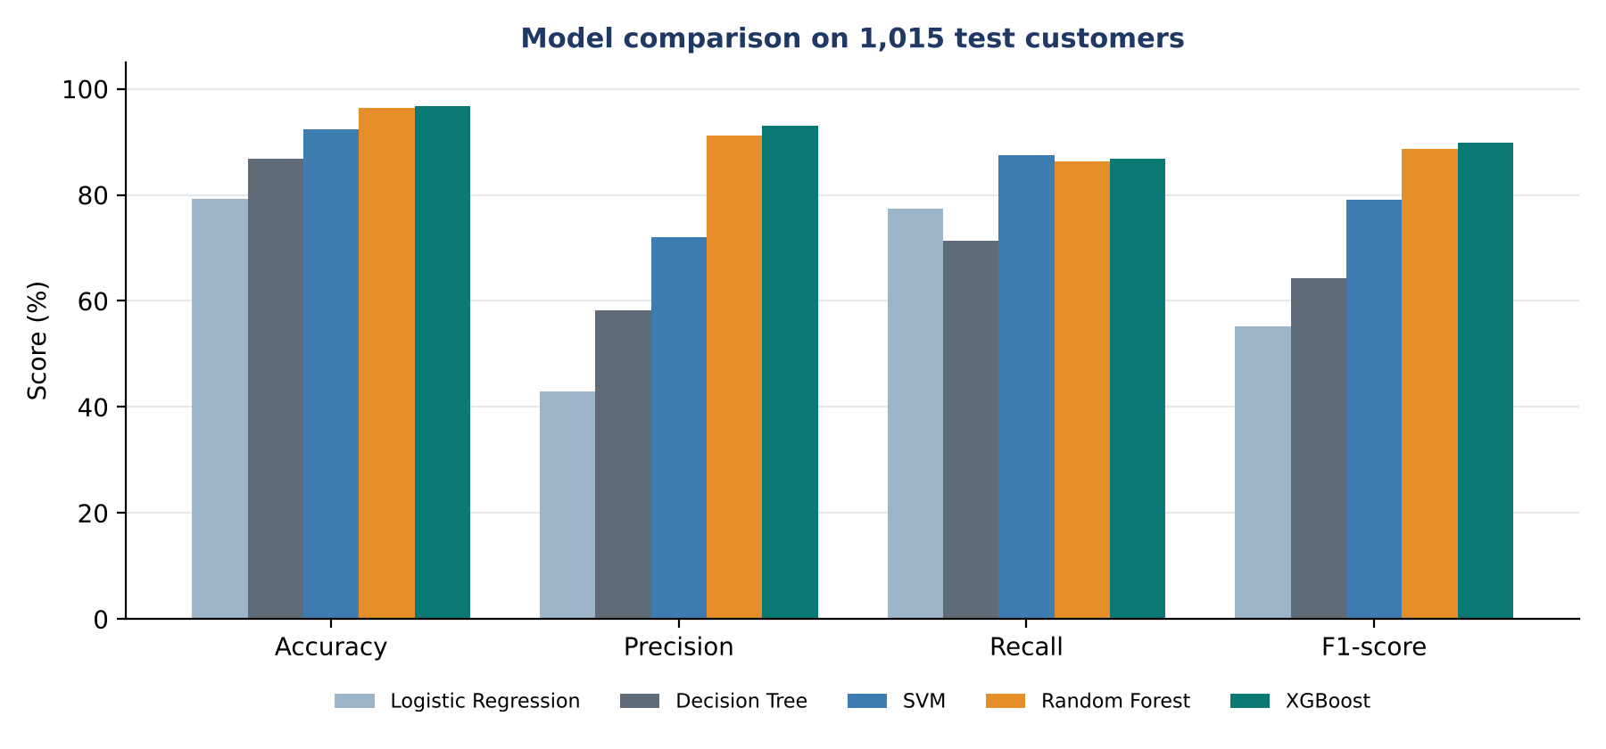
Fig No. 8.1 Comparison of the five models on the test set
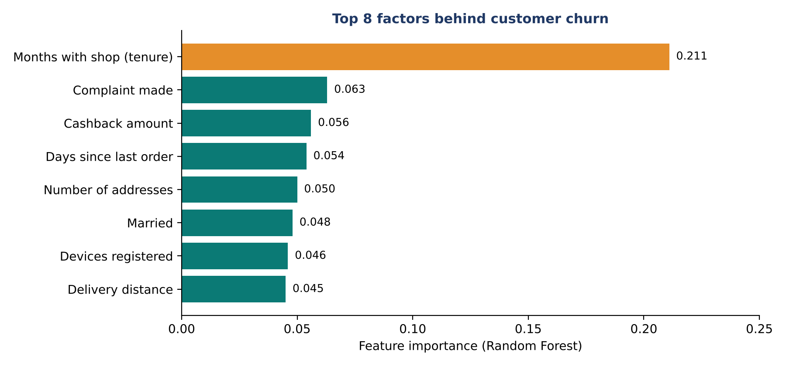
Fig No. 8.2 Main reasons for churn (Random Forest feature importance)
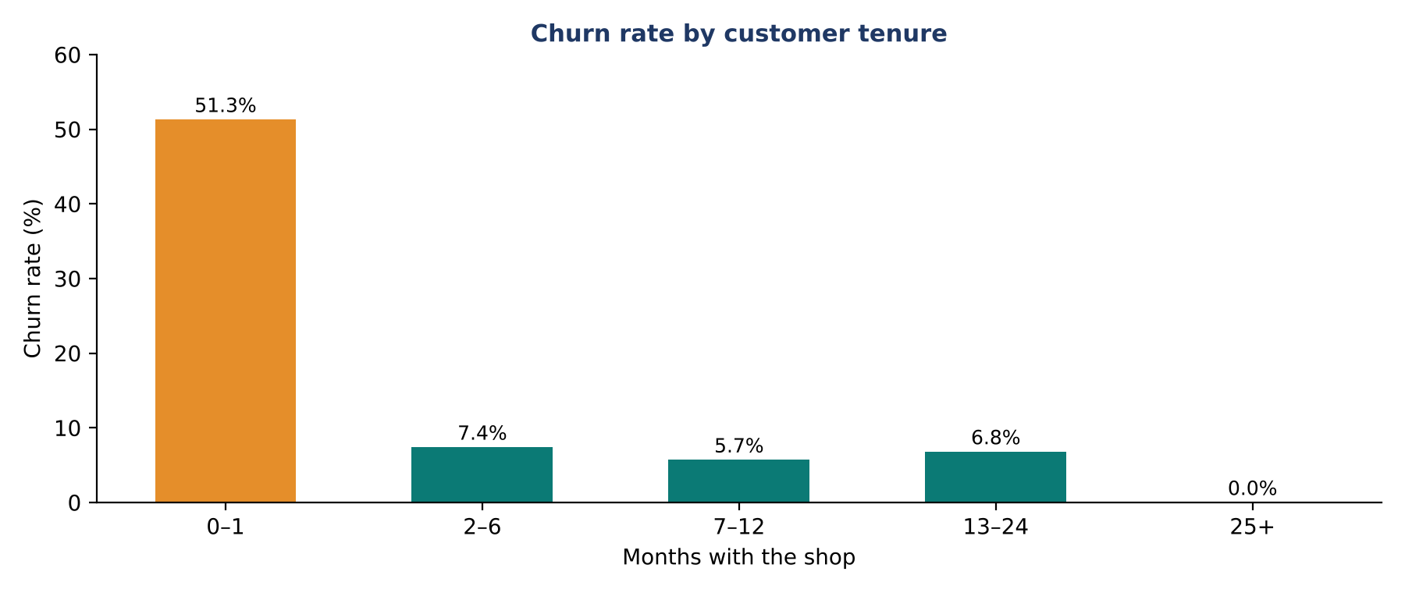
Fig No. 8.3 Churn rate by customer tenure

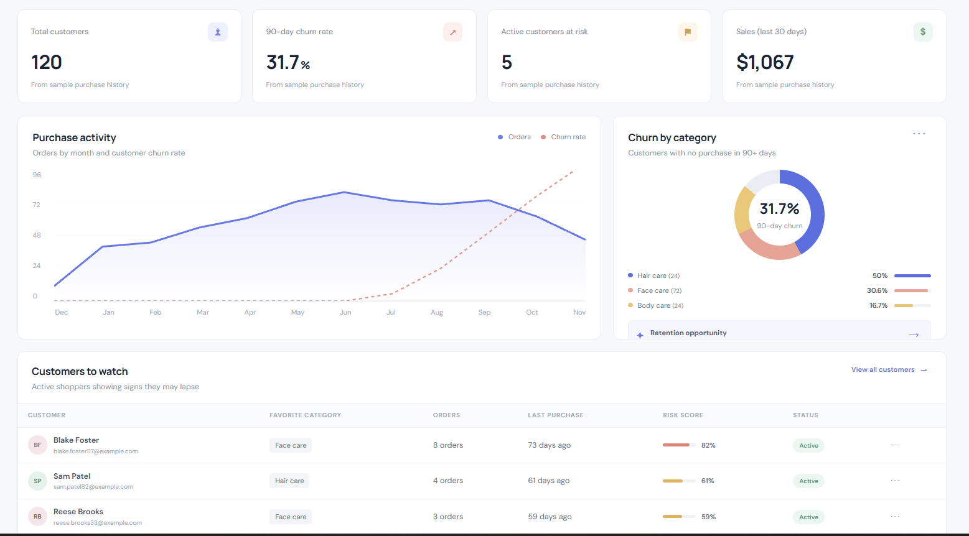
Fig No. 8.4 Overview dashboard
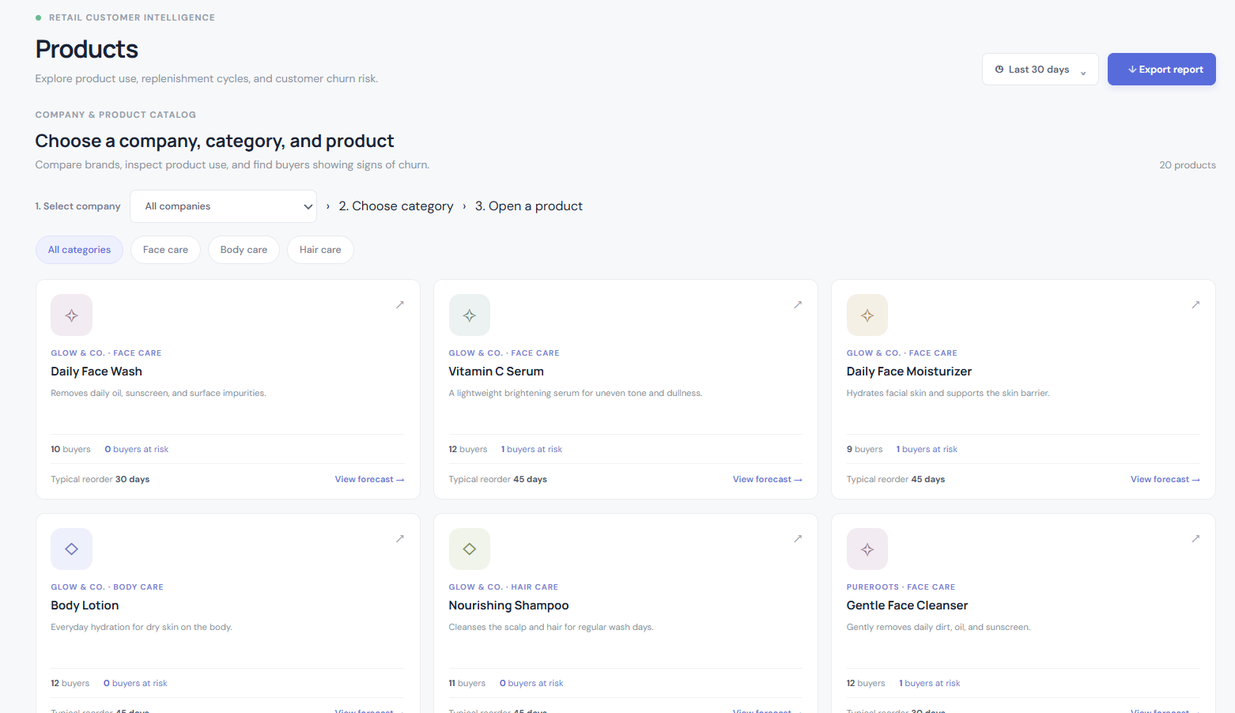
Fig No. 8.5 Products page
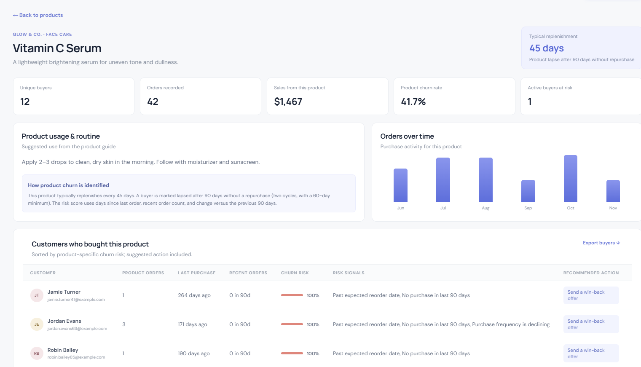
Fig No. 8.6 Product detail page with buyers at risk
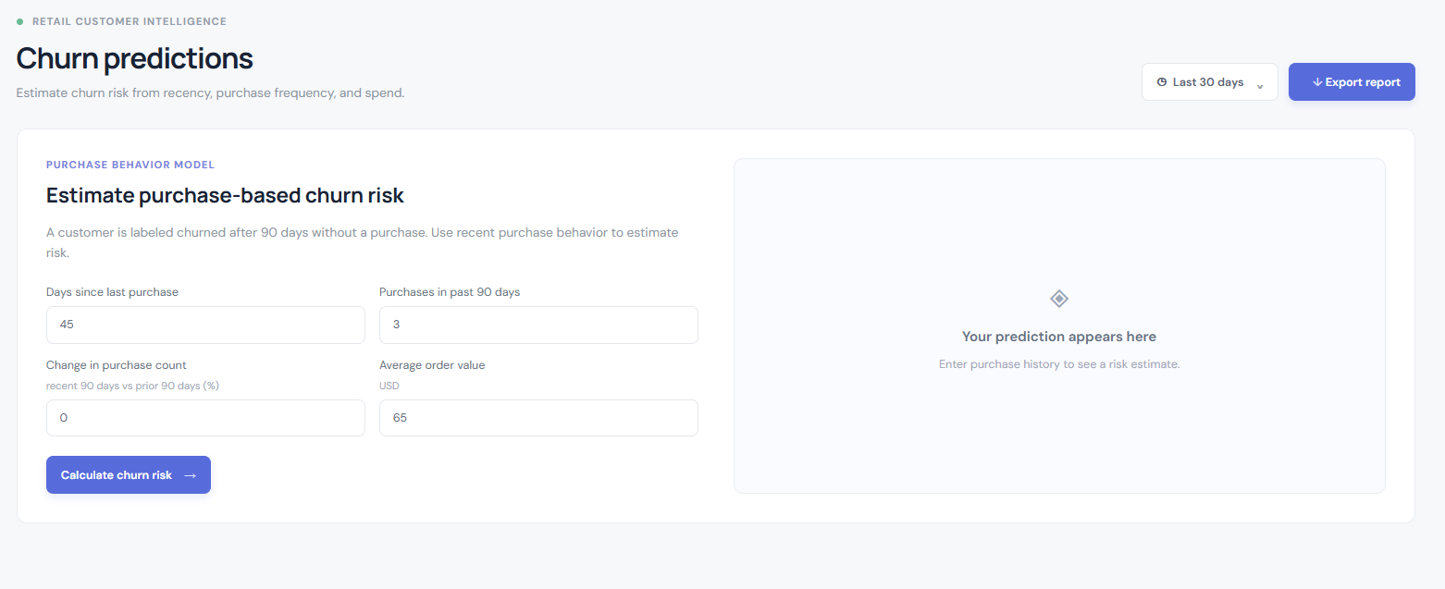
Fig No. 8.7 Churn predictions page

CHAPTER 9
Deployment

9.1 Steps to deploy
- Push the final code to the GitHub repository.
- Run the model and application tests; proceed only if all tests pass.
- Train the final XGBoost model and save it as models/churn_model.joblib.
- Create a requirements.txt listing the exact package versions.
- Create the database and run the schema script to create the tables.
- Deploy the Flask API to the server and set the environment variables.
- Deploy the web dashboard files and configure them with the API URL.
- Open the public URL and run a smoke test with a sample customer.

9.2 Environment configuration
Variable | Purpose
DATABASE_URL | Connection string of the database
SECRET_KEY | Key used to secure user sessions (never committed to Git)
MODEL_PATH | Location of the saved model file
API_URL | Address of the API used by the dashboard
RISK_LOW / RISK_HIGH | Probability thresholds for the risk groups (0.3 and 0.6)

Secrets are stored as environment variables on the host and are kept out of the source code. A virtual environment is used so that package versions are identical in development and production.
9.3 Hosting of frontend and backend
The Flask API and the web dashboard can be hosted on a cloud platform (for example Render, Railway or PythonAnywhere), with the static HTML, CSS and JavaScript files served alongside the API. HTTPS is enabled so that customer data is encrypted in transit. During the project the system was run on a local machine.
CHAPTER 10
Challenges & Limitations

10.1 Issues faced during development
- Class imbalance: only 1 in 6 customers left, so models tend to predict “stay” for everyone.
- Repeated rows: 556 duplicate rows in the dataset could make scores look better than they really are.
- Missing values: several columns had empty cells.
- Text columns: models read only numbers, but columns such as gender and preferred device were text.
- Different ranges: columns such as cashback and tenure have very different scales.
- Choice of threshold: the cut-off between risk groups changes how many customers receive offers.

10.2 Solutions applied
- Applied SMOTE to the training data only and judged models by recall and ROC-AUC instead of accuracy alone.
- Removed all 556 repeated rows before splitting, keeping 5,074 unique customers and honest results.
- Filled missing values with the median of each column.
- Encoded text columns into numbers (for example Male / Female → 0 / 1).
- Scaled numeric columns to a similar range so that no column dominates.
- Made the risk thresholds (0.3 and 0.6) configurable so the business can set its own budget for offers.

10.3 Current limitations or known bugs
- The model is trained on a static public dataset, not live shop data.
- Retention offers have not yet been tested on real customers.
- Individual predictions are not yet explained customer by customer.
- XGBoost still misses 22 of the 168 customers who left in the test set.
- The output is decision support and should be reviewed by a person before acting.

CHAPTER 11
Future Enhancements

11.1 Planned features
- Use live shop data and retrain the model regularly.
- Explain each prediction so the user can see why a particular customer is at risk.
- Build a richer interactive dashboard of purchasing trends, churn rates and business insights.
- Test offers on real customers and measure which actions actually keep buyers.
- Add a query box so users can ask questions about customer purchase data and results.
- Add a product recommendation system based on previous purchase history.

11.2 Possible integrations or optimizations
- SMS and e-mail notification tools to alert the business about customers who are likely to churn and send win-back messages.
- Integration with the shop’s CRM or order management system through the REST API.
- Experiments with deep learning and stacked ensembles to further improve recall.
- Containerization with Docker for easy, large-scale deployment.
- A mobile-friendly version of the dashboard for shop owners on the move.

CHAPTER 12
Conclusion

12.1 Summary of the project
Customer Churn Prediction and Analytics Using Machine Learning applies data science to an important business problem: finding which customers are about to stop buying, and why. The system uses an e-commerce purchase dataset, cleans it carefully, studies churn patterns with charts, and applies Logistic Regression, Decision Tree, SVM, Random Forest and XGBoost to predict churn and group customers into risk levels with suggested actions.
12.2 What was achieved
- Built an end-to-end churn workflow from data collection to risk groups and actions.
- Removed 556 repeated rows to keep the results honest, leaving 5,074 customers.
- XGBoost was the best model: 96.7% accuracy, 93.0% precision, 86.9% recall and 0.985 AUC.
- Found that tenure and complaints matter most: 51.3% of first-month customers and 31.3% of complainers leave.
- Created risk groups that work in practice: 94.3% of High-risk customers really left, against 1.3% of Low-risk customers.
- Designed a web dashboard with overview, product-wise churn and churn prediction pages.

The system helps businesses understand customer behaviour, identify potential customer loss early and take the right steps to improve retention. We hope that this project will help businesses make better decisions, improve customer relationships and increase their overall growth.
12.3 Skills learned during development
- Data cleaning, exploratory data analysis and data preparation using Python.
- Supervised machine learning, model evaluation and handling of imbalanced data with SMOTE.
- Understanding of customer retention concepts such as churn rate, tenure and win-back offers.
- Building web pages with HTML, CSS, Bootstrap and JavaScript and connecting them to a model.
- Version control with Git and GitHub.
- Teamwork, documentation and technical report writing.

CHAPTER 13
References

The following papers, books and documentation sites are the main sources for this project:
- Al-Amin et al., “Customer Churn Prediction in Telecom Sector with Machine Learning and Information Gain Filter Feature Selection Algorithms,” IEEE Xplore, 2021.
- Shrestha et al., “A Customer Churn Prediction Model using XGBoost for the Telecommunication Industry in Nepal,” ScienceDirect, 2022.
- Zhou et al., “Early Warning of Telecom Enterprise Customer Churn Based on Ensemble Learning,” PLOS ONE, 2023.
- Sikri et al., “Enhancing Customer Retention in Telecom Industry with Machine Learning Driven Churn Prediction,” Scientific Reports, 2024.
- Abdelhady and Mohamed, “Leveraging Artificial Intelligence for Predictive Customer Churn Modeling in Telecommunications,” Scientific Reports, 2025.
- N. V. Chawla et al., “SMOTE: Synthetic minority over-sampling technique,” J. Artif. Intell. Res., vol. 16, pp. 321–357, 2002.
- T. Chen and C. Guestrin, “XGBoost: A scalable tree boosting system,” in Proc. ACM SIGKDD, 2016, pp. 785–794.
- “E-Commerce Customer Churn Analysis and Prediction” dataset (public) – https://www.kaggle.com/datasets
- scikit-learn documentation – https://scikit-learn.org/stable/user_guide.html
- imbalanced-learn documentation – https://imbalanced-learn.org/stable/
- XGBoost documentation – https://xgboost.readthedocs.io/
- W3Schools HTML, CSS and Bootstrap tutorials – https://www.w3schools.com/
- Bootstrap documentation – https://getbootstrap.com/docs/

CHAPTER 14
Appendices

14.1 Screenshots of the app
Screenshots of the application are shown in Chapter 8: (a) Overview dashboard (Fig No. 8.4), (b) Products page (Fig No. 8.5), (c) Product detail page with buyers at risk (Fig No. 8.6) and (d) Churn predictions page (Fig No. 8.7).
14.2 Sample code snippets
A. Training the model (train.py)
import pandas as pd, joblib
from sklearn.model_selection import train_test_split
from sklearn.compose import ColumnTransformer
from sklearn.pipeline import Pipeline
from sklearn.impute import SimpleImputer
from sklearn.preprocessing import StandardScaler, OneHotEncoder
from sklearn.metrics import classification_report, roc_auc_score
from imblearn.over_sampling import SMOTE
from xgboost import XGBClassifier
df = pd.read_csv("data/ecommerce_churn.csv")
df = df.drop(columns=["CustomerID"]).drop_duplicates() # 5,630 -> 5,074
y = df["Churn"]
X = df.drop(columns=["Churn"])
num_cols = X.select_dtypes("number").columns
cat_cols = X.select_dtypes("object").columns
pre = ColumnTransformer([
("num", Pipeline([("imp", SimpleImputer(strategy="median")),
("sc", StandardScaler())]), num_cols),
("cat", OneHotEncoder(handle_unknown="ignore"), cat_cols),
])
X_tr, X_te, y_tr, y_te = train_test_split(X, y, test_size=0.2, random_state=42)
X_tr_p = pre.fit_transform(X_tr)
X_te_p = pre.transform(X_te)
X_bal, y_bal = SMOTE(random_state=42).fit_resample(X_tr_p, y_tr) # training only
model = XGBClassifier(eval_metric="logloss", random_state=42)
model.fit(X_bal, y_bal)
proba = model.predict_proba(X_te_p)[:, 1]
print("ROC-AUC:", roc_auc_score(y_te, proba))
print(classification_report(y_te, proba > 0.5))
joblib.dump({"pre": pre, "model": model}, "models/churn_model.joblib")
B. Prediction API (app.py)
from flask import Flask, request, jsonify
import joblib, pandas as pd
app = Flask(__name__)
bundle = joblib.load("models/churn_model.joblib")
ACTIONS = {"Low": "No extra spend; keep normal engagement",
"Medium": "Win-back message with a special deal",
"High": "Extra cashback and complaint call-back in 24 hours"}
def risk_group(p):
if p < 0.30:
return "Low"
if p <= 0.60:
return "Medium"
return "High"
@app.post("/predict")
def predict():
data = request.get_json()
X = bundle["pre"].transform(pd.DataFrame([data]))
p = float(bundle["model"].predict_proba(X)[0, 1])
g = risk_group(p)
return jsonify(churn_probability=round(p, 4), risk_group=g, action=ACTIONS[g])
C. Front-end script (predict.js)
document.getElementById("calcBtn").addEventListener("click", async () => {
const payload = {
days_since_last_purchase: +document.getElementById("days").value,
purchases_90d: +document.getElementById("purchases").value,
change_in_purchases: +document.getElementById("change").value,
avg_order_value: +document.getElementById("aov").value
};
const res = await fetch("/predict", {
method: "POST",
headers: {"Content-Type": "application/json"},
body: JSON.stringify(payload)
});
const out = await res.json();
document.getElementById("result").innerText =
(out.churn_probability * 100).toFixed(1) + "% – " + out.risk_group + " risk";
});
14.3 Installation/setup instructions
- Install Python 3.10 or later and Git.
- Clone the repository: git clone <repository-url> and open the project folder.
- Create a virtual environment: python -m venv venv and activate it.
- Install the dependencies: pip install -r requirements.txt
- Place the dataset in the data/ folder as ecommerce_churn.csv.
- Train the model: python train.py
- Start the application: python app.py
- Open http://localhost:5000 in the browser.

14.4 User manual or guide
- Log in with the username and password given by the administrator.
- Open the Overview page to see total customers, the 90-day churn rate and customers to watch.
- Open Products, choose a company and category, and open a product to see buyers at risk.
- Open Churn Predictions and enter the customer’s purchase behaviour.
- Press Calculate churn risk and read the churn probability and risk group.
- Follow the suggested action, for example send a win-back offer to a High-risk customer.
- Use Export report to share the results with the marketing team.

